dsAmerican University of Sharjah  College of Engineering  Dept of Computer Science and Engineering  P. O. Box 26666  Sharjah, UAE |  | Lab Instructor: Ms. Salsabeel Shapsough  Office: ESB-1010A  Phone: +971 6 515 4948  e-mail: sshapsough@aus.edu  Semester: Fall 2024

Lab #5 – Code conversions and Rotation
Objectives
- Design and build code converters.
- Design and build bit rotation circuit.

Lab Equipment and Circuit Components
a. Equipment
- Breadboard
- Switches and LEDs
- Connectors

  - Circuit Components
- 7486 (XOR), 7432 (OR) chips

Lab Exercises:
Exercise 1:
From the K-map in Figure 3

 | C’D’  0 0 | C’D  0 1 | CD  1 1 | CD’  1 0
A’B’  0 0 | 1 | 0 | 1 | 1
A’B  0 1 | 0 | 0 | 0 | 0
AB  1 1 | 0 | 0 | 1 | 1
AB’  1 0 | 1 | 1 | 1 | 1
Figure 3. F (A, B, C, D)
- Simplify the circuit.
- Simulate the simplified circuit on LogiSim.
- Implement the simplified circuit on the breadboard.
Exercise 2:
Bit rotation is an operation similar to shift except that the bits that fall off at one end are put back to the other end. In left rotation, the bits that fall off at left end are put back at right end. In right rotation, the bits that fall off at the right end are put back at the left end.
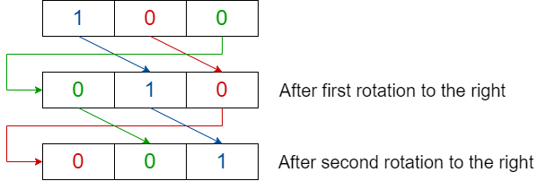

- Build the truth table for a circuit that takes a 3-bit binary number as input and outputs the 3-bit binary number after a rotation of one position to the right.
- Simply the expression by extracting the SOP and applying Boolean algebra rules.
- Verify your answer using a 3 variable Karnaugh map.
- Simulate your circuit.
- Implement and verify the operation .

Exercise 3:
The positional encoder in Figure 1 uses Gray code to represent the position of the pointer. E.g. when the pointer is in the 3rd area, the output is 0010. Gray code is one of the codes used in digital systems. It has the advantage over binary numbers in that only one bit in the code word changes when going from one number to the next, which eliminates the error when the pointer moves between areas. Example: Gray Code 0101 represents the Binary Code 0110, i.e., 6.

- Design a combinational circuit with four inputs and four outputs that converts the four-bit binary number into an equivalent Gray Code. You may refer to the truth table below.
- Use the Karnaugh map technique to simplify the expression. Hint: You can rewrite the expression to use the minimum number of gates.
- Simulate the circuit of the simplified form
- Implement and verify the operation

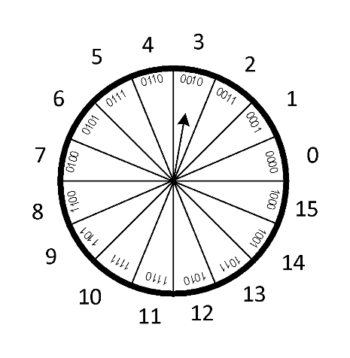

 | A | B | C | D | O1 | O2 | O3 | O4
0 | 0 | 0 | 0 | 0 | 0 | 0 | 0 | 0
1 | 0 | 0 | 0 | 1 | 0 | 0 | 0 | 1
2 | 0 | 0 | 1 | 0 | 0 | 0 | 1 | 1
3 | 0 | 0 | 1 | 1 | 0 | 0 | 1 | 0
4 | 0 | 1 | 0 | 0 | 0 | 1 | 1 | 0
5 | 0 | 1 | 0 | 1 | 0 | 1 | 1 | 1
6 | 0 | 1 | 1 | 0 | 0 | 1 | 0 | 1
7 | 0 | 1 | 1 | 1 | 0 | 1 | 0 | 0
8 | 1 | 0 | 0 | 0 | 1 | 1 | 0 | 0
9 | 1 | 0 | 0 | 1 | 1 | 1 | 0 | 1
10 | 1 | 0 | 1 | 0 | 1 | 1 | 1 | 1
11 | 1 | 0 | 1 | 1 | 1 | 1 | 1 | 0
12 | 1 | 1 | 0 | 0 | 1 | 0 | 1 | 0
13 | 1 | 1 | 0 | 1 | 1 | 0 | 1 | 1
14 | 1 | 1 | 1 | 0 | 1 | 0 | 0 | 1
15 | 1 | 1 | 1 | 1 | 1 | 0 | 0 | 0

